Using ZOOM Sheet
Read more about STEMLinc here: https://learnonline.ecolinc.vic.edu.au/stem-linc-events/
You teacher has booked you into one of Ecolinc’s exciting video conference programs. This sheet will show you how to prepare for your lesson using ZOOM – it’s really easy!
What devices does ZOOM work on?
- Phone
- Ipad
- Computer

For phones and ipads:
- You will need to download and install the ZOOM app.
- Then you open ZOOM on your device and enter the meeting number that your teacher sends you and the passcode to enter the meeting at the right time.

For computers:

Preparation for using ZOOM

- Google ZOOM.us
- Install the program onto your computer (it only takes a few minutes)
- Now you are ready to click the ZOOM link your teacher emails through to you so you can enter the meeting at the right time. Your teacher will also give you a passcode to enter when ZOOM asks for it.

What is the best device to use with ZOOM?

We recommend using a computer if possible so that you have a larger monitor and can access to all of the tools. An ipad would be our second preference, followed lastly by a phone.

Joining a meeting with ZOOM

- Open ZOOM application on your laptop, ipad or phone (or open the ZOOM website on a browser like Explorer).
- Click the blue “Join a Meeting” button

- Enter the meeting number your teacher sent to you into the Meeting ID box
- Put your Christian name into the box below

NOTE: Your teacher might want you to turn off your video by selecting that option at the bottom. They will have told you if that is the case. That means that no one can see you but you can see the Presenter and hear the other students.

- Click the grey ‘Join’ button at the bottom of the window

- The password box opens. Enter the password that your teacher sent through to you.
- Click the grey button: Join the Meeting

- You will now either be taken to the ‘waiting room’ or the host (presenter) might have arranged for you to go directly into the lesson area to wait.

The Waiting Room screen looks like this:

This window shows you that host ECOLINC has put you into the waiting room for the meeting to start at the exact time. Please wait patiently for the presenter to let you into the meeting at the arranged time. Your microphone should be on MUTE at all times unless the Presenter or your teacher asks you to answer a question.

(If you need to test your computer audio as you wait, you can click that button and speak. You should see green lines appear as sound waves matching you voice. Close the settings window by clicking the cross in the top right hand corner. )

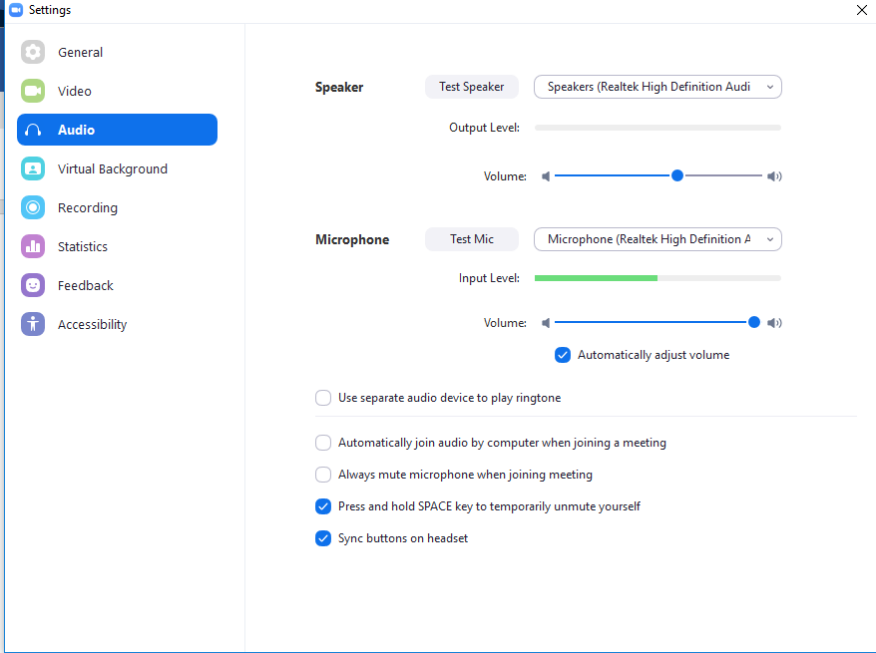

The Lesson area screen will look something like this:

Just wait patiently until your lesson begins. Your microphone should be on MUTE at all times unless the Presenter or your teacher asks you to answer a question.

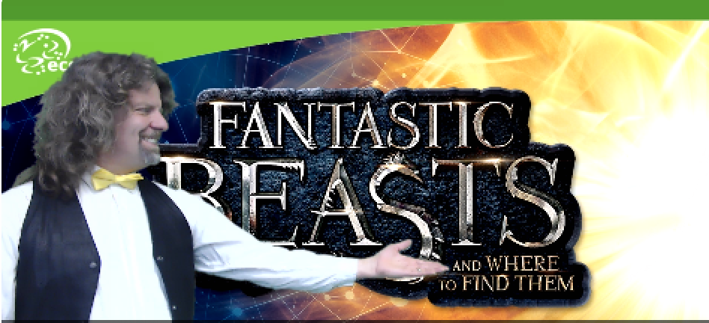

NOTE: If prompted you need to select the dark blue button: Join with Computer Audio (See below)

During the Meeting

We are now in a ZOOM meeting.

How do I turn my sound and video on and off?

- Down in the bottom left hand corner you can see a red line through my microphone and a red line through my video. That means that I will see and hear the Presenter but others cannot see me. To activate your microphone when directed you can click on the Unmute button or your Presenter may take control of that feature.

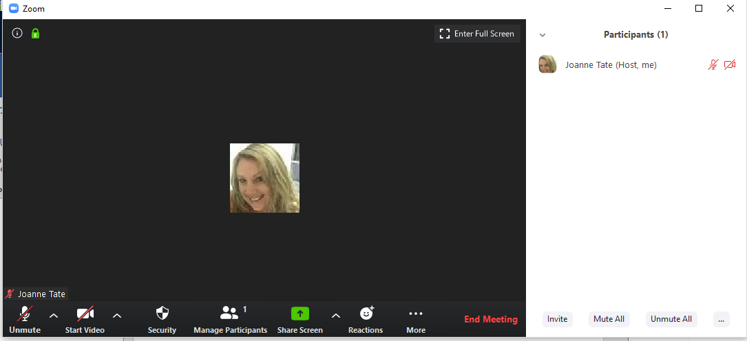

How do I indicate Yes and No?

- You have a reactions button at the bottom of your screen. If your presenter asks you a question you can indicate Yes or No using these reactions.

How do I ask questions?

- During the presentation you might think of questions that you would like the Presenter to answer. Type these in the Chat box by clicking on the ...More icon at the bottom of your screen. DO NOT use the chat box for anything other than questions.

How do I interact with a document?

- Your presenter might share a document or power point with you. Sometimes they might ask you to interact with the document. Roll your mouse to the top of your screen you will see a drop down menu that has an option to Annotate. This opens up tools that your Presenter may ask you to use. Alternately, your presenter may use the tools themselves on the open document to highlight some information.
DO NOT use the tools on the shared document unless directed to do so.

How do I leave the lesson?
- When the lesson is over you need to click the End Meeting button at the bottom of the ZOOM window.
Have a play with ZOOM
TIP: Did you know you can open up your own ZOOM meeting and have a play with sharing your screen and using the tools outlined in this handout. It would be a great idea to do so before your next Ecolinc lesson!

