Victorian Challenge and Enrichment Series Nomination
Presented to
<insert name of student>
Congratulations on being nominated to participate in the
Victorian Challenge and Enrichment Series activity:
‘STEAM Ahead’ – Dinosaur Dynamics
presented by
Ecolinc Science and Technology Innovations Centre
on
Thursday 24th November 2022.
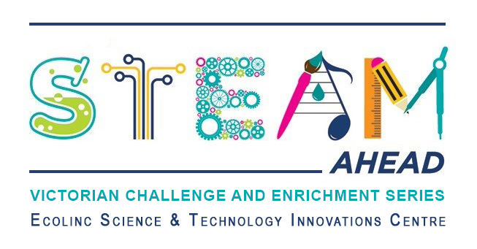
<insert name of teacher>
<insert name of school>

