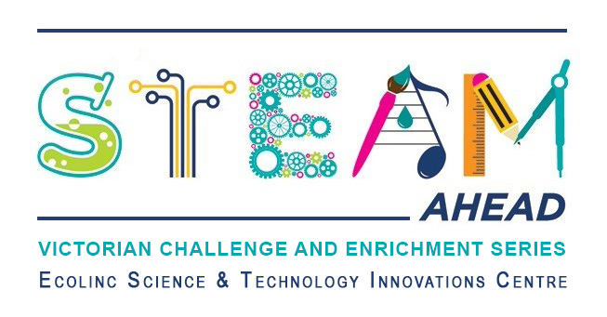
Dear parent/guardians,
Ecolinc’s S.T.E.A.M Ahead program is part of the Victorian Challenge and Enrichment Series, an initiative of the Department of Education and Training that provides enrichment opportunities to extend high ability students in Victorian government schools so that they are better supported to excel and reach their full potential.
Your son/daughter ________________________________ has been selected to participate in the S.T.E.A.M Ahead ‘Secrets of Eromanga’ program on Wednesday 23rd November 2022.
‘Secrets of Eromanga’ has been designed for Years 3-4 high ability students. Palaeontologist and PhD Candidate, Tim Richards, from the University of Queensland will lead an exciting presentation followed by a Q&A session. The theme will be fossil clues from what was once the Eromanga inland sea. A short break will then be followed by an engaging hands-on session where students will work on a trilobite fossil sketch suited to a paleontological field journal. They will discover fascinating facts about this now extinct animal as they prepare their sketch.
This program is fully subsidised and therefore there is no cost to participate. The program will be delivered virtually via video conference.
_________________________________________________________________________________
Victorian Challenge and Enrichment Series
S.T.E.A.M Ahead – Secrets of Eromanga

I give permission for my child _________________________________________ to participate in the
VCES S.T.E.A.M Ahead – Secrets of Eromanga program on Wednesday 23rd November 2022.
I understand that this program will be delivered virtually by Ecolinc Science & Technology Innovation Centre (Department of Education & Training).

Parent name: Date:
Signature:

_________________________________________________________________________________

