Victorian Challenge and Enrichment Series Nomination
Presented to
<insert name of student>
Congratulations on being nominated to participate in the
Victorian Challenge and Enrichment Series activity:
‘STEAM Ahead’ – Insectivores 101
presented by
Ecolinc Science and Technology Innovations Centre
On
4th April 2023.
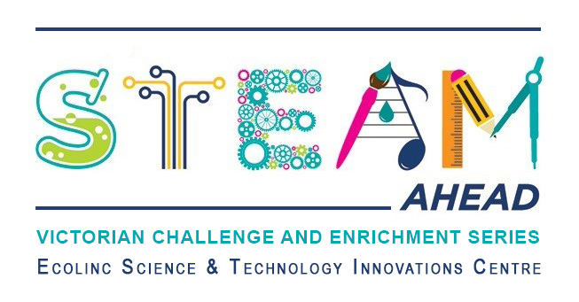
<insert name of teacher>
<insert name of school>

