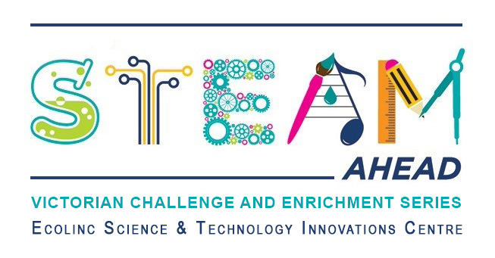
Dear parent/guardians,
Ecolinc’s S.T.E.A.M Ahead program is part of the Victorian Challenge and Enrichment Series, an initiative of the Department of Education and Training that provides enrichment opportunities to extend high ability students in Victorian government schools so that they are better supported to excel and reach their full potential.
Your son/daughter ________________________________ has been selected to participate in the S.T.E.A.M Ahead ‘Insectivores 101’ program on Tuesday 4th April 2023.
‘Insectivores 101’ has been designed for Years 5-6 high ability students. Entomologist and PhD Candidate, Shasta Henry, from the University of Tasmania will lead an exciting presentation followed by a Q&A session (40 mins). The theme will be ‘Did you know that insects are the superfood of the future?
Students will then have a short break followed by an engaging hands-on session (60 mins) where students will conduct a scientific taste-testing trial, respond to a series of super-food insect breeding challenges, and investigate the impact of introducing a new insect super-species into our environment.
This program is fully funded and therefore there is no cost to participate. The program will be delivered virtually via video conference.
_________________________________________________________________________________
Victorian Challenge and Enrichment Series
S.T.E.A.M Ahead – ‘Insectivores 101’
I give permission for my child _________________________________________ to participate in the
VCES S.T.E.A.M Ahead – Insectivores 101 program on Tuesday April 4th 2023.
I understand that this program will be delivered virtually by Ecolinc Science & Technology Innovation Centre (Department of Education & Training).

Parent name: Date:
Signature:
_________________________________________________________________________________

