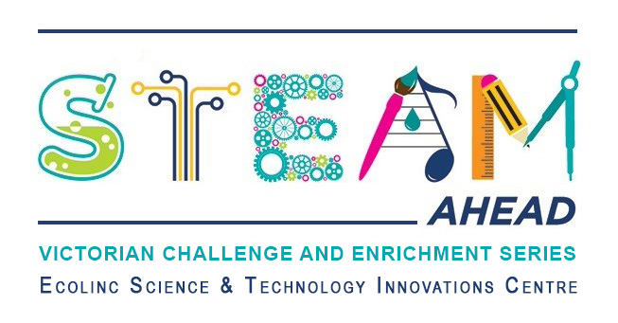
Dear parent/guardians,
Ecolinc’s S.T.E.A.M Ahead program is part of the Victorian Challenge and Enrichment Series, an initiative of the Department of Education and Training that provides enrichment opportunities to extend high ability students in Victorian government schools so that they are better supported to excel and reach their full potential.
Your son/daughter ________________________________ has been selected to participate in the S.T.E.A.M Ahead ‘Pterosaurs: Giants of the Skies’ program on Wednesday 28th February 2024 via video conference.
‘Pterosaurs: Giants of the Skies’ has been designed for Years 5-6 high ability students. Palaeontologist and PhD Candidate, Tim Richards, from the University of Queensland will lead an exciting presentation followed by a Q&A session. The theme will be what clues do Palaeontologists use to establish the existence of Pterosaurs in Australia. A short break will then be followed by an engaging hands-on session called Dragonstem where students, acting as junior Palaeontologists, will evaluate fossil evidence to explore the mythology of Dragons.

This program is fully subsidised and therefore there is no cost to participate. The program will be delivered virtually via video conference.
_________________________________________________________________________________
Victorian Challenge and Enrichment Series
S.T.E.A.M Ahead – Pterosaurs: Giants of the Skies
I give permission for my child _________________________________________ to participate in the
VCES S.T.E.A.M Ahead – Pterosaurs: Giants of the Skies program on Wednesday 28th February 2024.
I understand that this program will be delivered virtually by Ecolinc Science & Technology Innovation Centre (Department of Education & Training).

Parent name: Date:
Signature:

_________________________________________________________________________________

