Victorian Challenge and Enrichment Series Nomination
Presented to
<insert name of student>
Congratulations on being nominated to participate in the
Victorian Challenge and Enrichment Series activity:
‘STEAM Ahead’ – Pterosaurs: Giants of the Skies
presented by
Ecolinc Science and Technology Innovations Centre
on
Monday 3rd April 2023.
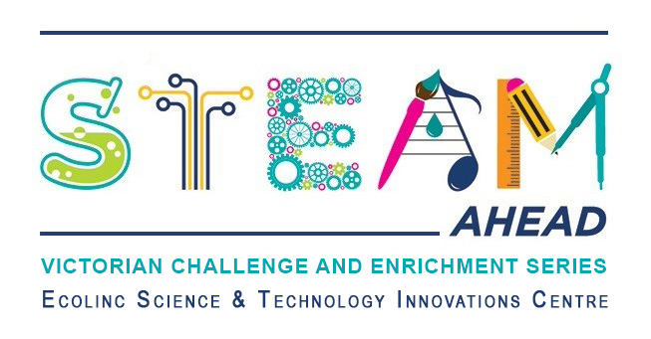
<insert name of teacher>
<insert name of school>

