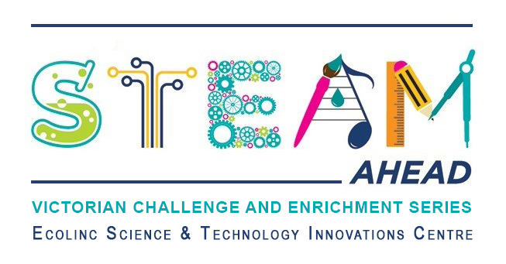
Dear parent/guardians,
Ecolinc’s S.T.E.A.M Ahead program is part of the Victorian Challenge and Enrichment Series, an initiative of the Department of Education and Training that provides enrichment opportunities to extend high ability students in Victorian government schools so that they are better supported to excel and reach their full potential.
Your son/daughter ________________________________ has been selected to participate in the S.T.E.A.M Ahead ‘Space Junk & Salvaging Satellites’ program on either Monday 15th May or Tuesday 16th May 2023.
‘Space Junk & Salvaging Satellites has been designed for Years 5-6 high ability students. Associate Professor Brett Carter from RMIT will lead an exciting presentation followed by a Q&A session (40 mins). The theme will be ‘What and why is Space Junk such a problem for us on earth?’
Students will then have a short break followed by an engaging hands-on session (60 mins) where students will design a method for bringing end-of-life satellites back to earth safely.
This program is fully funded and therefore there is no cost to participate. The program will be delivered virtually via video conference.
_________________________________________________________________________________
Victorian Challenge and Enrichment Series
S.T.E.A.M Ahead – ‘Space Junk & Salvaging Satellites’
I give permission for my child _________________________________________ to participate in the
VCES S.T.E.A.M Ahead – Space Junk & Salvaging Satellites’ program on either Monday 15th May or Tuesday 16th May 2023.
I understand that this program will be delivered virtually by Ecolinc Science & Technology Innovation Centre (Department of Education & Training).

Parent name: Date:
Signature:
_________________________________________________________________________________

