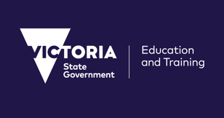**VICTORIAN CHALLENGE AND ENRICHMENT SERIES**

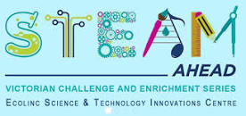

**Space Junk: Salvaging Satellites**

**Space Junk: Salvaging Satellites**

**Date:** Monday 15th May 2023 **OR** Tuesday 16th May (Select either of the dates)

**Suitability:** Years 5-6 high ability students

**Delivery mode:** Video Conference

**Available times:**

* 10 am – 12 pm
* 1 pm – 3 pm

**Note:** Two identical sessions are run on the day. Select either the morning or afternoon session. **Only ONE ticket of up to 25 high ability students per school for each VCES event.**

**Morning program details:**

**10 – 10.45 am**: *Space Junk: a waste threat.*  Presentation by Associate Professor Brett Carter with Q & A session

**10.45 – 11 am**: Break time

**11 am – 12 pm:** *Salvaging Satellites* aninteractive hands-on session

**Afternoon program details:**

**1 – 1.45 pm**: *Space Junk: a waste threat.*  Presentation by Associate Professor Brett Carter with Q & A session

**1.45 – 2pm:** Breaktime

**2 pm – 3 pm:** *Salvaging Satellites* interactive hands-on session

**Materials:** A STEM-in-a-box kit of materials will be sent free of charge and a student handout will be sent prior to the event.



Brett Carter is a Space Scientist who grew up in Altona, Victoria. He went to Altona Primary School and then Williamstown High School before studying space science at La trobe University in Bundoora. He then became a research scientist at RMIT University in Melbourne. He also spent 2 years working on space science in Boston in the United States, but he’s now back in Australia and works at RMIT University as an Associate Professor, teaching space science to university students and doing research on space weather and satellite/space junk tracking.

