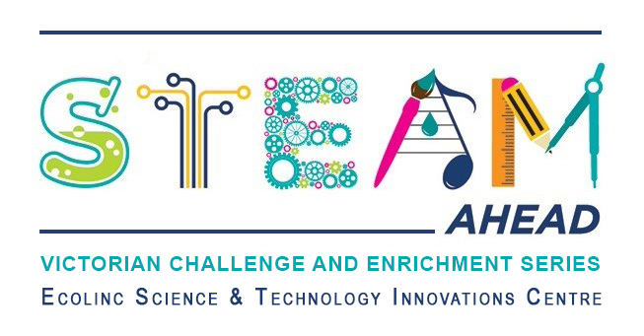
Dear parent/guardians,
Ecolinc’s S.T.E.A.M Ahead program is part of the Victorian Challenge and Enrichment Series, an initiative of the Department of Education and Training that provides enrichment opportunities to extend high ability students in Victorian government schools so that they are better supported to excel and reach their full potential.
Your son/daughter ________________________________ has been selected to participate in the S.T.E.A.M Ahead ‘Challenging Climate Change’ program on Wednesday 20th or Thursday 21st November 2024 via video conference.
‘Challenging Climate Change’ has been designed for Years 5-6 high ability students. Ice-Core Scientist Chelsea Long (Australian Antarctic Division) will lead an exciting hands-on workshop. This follows an opening Q&A session live from New York’s Liberty Science Centre. What climate secrets do ice cores hold from Earth’s past? How can we interpret data to understand climate change? Students will engage with their own ice-core model in this workshop!

This program is fully subsidised and therefore there is no cost to participate. The program will be delivered virtually via video conference.
_________________________________________________________________________________
Victorian Challenge and Enrichment Series
S.T.E.A.M Ahead – Challenging Climate Change

I give permission for my child _________________________________________ to participate in the
VCES S.T.E.A.M Ahead –Challenging Climate Change program on Wednesday 20th or Thursday 21st November 2024.
I understand that this program will be delivered virtually by Ecolinc Science & Technology Innovation Centre (Department of Education & Training).

Parent name: Date:
Signature:
_________________________________________________________________________________

