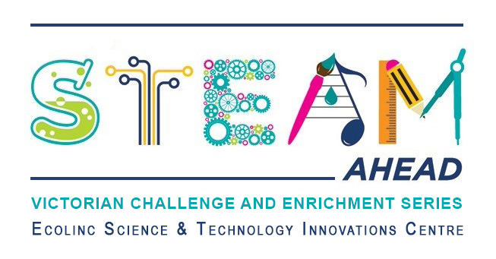
Dear parent/guardians,
Ecolinc’s S.T.E.A.M Ahead program is part of the Victorian Challenge and Enrichment Series, an initiative of the Department of Education and Training that provides enrichment opportunities to extend high ability students in Victorian government schools so that they are better supported to excel and reach their full potential.
Your son/daughter ________________________________ has been selected to participate in the S.T.E.A.M Ahead ‘The Science of Climate Change’ program on Wednesday 19th or Thursday 20th November 2025 via video conference.
‘The Science of Climate Change’ has been designed for Years 5-6 high ability students. New York’s Liberty Science Centre will lead a video conference presentation explaining the science of climate change with a Q & A session. A short break will follow and then students will participate in a hands-on workshop investigating the climate secrets that ice cores hold from Earth’s past? Students will interpret ice-core data to understand about climate change? Students will engage with their own ice-core model in this workshop!

This program is fully subsidised and therefore there is no cost to participate. The program will be delivered virtually via video conference.
_________________________________________________________________________________
Victorian Challenge and Enrichment Series
S.T.E.A.M Ahead – The Science of Climate Change

I give permission for my child _________________________________________ to participate in the
VCES S.T.E.A.M Ahead – The Science of Climate Change program on Wednesday 19th or Thursday 20th November 2025.
I understand that this program will be delivered virtually by Ecolinc Science & Technology Innovation Centre (Department of Education & Training).

Parent name: Date:
Signature:
_________________________________________________________________________________

